

High Level Design Document
for
Flex Billing KPIs
& Reporting

Document Information

Version | 0.2 | Version Release Date | 12/20/2019
Author(s) | Aravinda A.R | Document Status | Initial
Storage |  | Template Version, date
Restriction | Joint Confidential
Revision History
Version | Date | Description | Author
0.1 | 12-Dec-2019 | Initial | Aravinda A. R
0.2 | 20-Dec-2019 | More granular level details added | Aravinda A. R

Reviewers
Name | Title | Responsibility
Mr. Sisir Samanta | Consultant, IT Architecture
Mr. Mahesh Kancharla | Senior Manager, Software Engineer IT
Mr. Arun Gupta | Principal Software Engineer – IT

Approvers
Title/Department | Responsibility | Date | Signature
Mr. Sisir Samanta
Mr. Mahesh Kancharla

1 About this Document 4
1.1 Introduction 4
1.2 Scope 4
1.3 Objective 4
1.4 Audience 4
1.5 Associated Documents 4
1.6 Acronyms, Terms and Definitions 5
2 End to End Solution Description 5
2.1 Key Design decisions/Patterns considered 5
2.2 Functional Architecture 6
2.2.1 Solution Components 6
2.3 High Level Integration Architecture 7
2.3.1 Interface Repository 8
3 High Level Solution Overview 8
3.1 Oracle BRM 8
3.2 Oracle Golden Gateway 8
3.3 Enterprise Data Ware house 9
3.3.1 Staging Area 9
3.3.2 Extraction Transformation Loading (ETL) 10
3.3.3 EDW Schema 11
3.4 User Interface (UI) with D3 (Data Driven Documents) 14
4 KPIs ( Key Performance Indicators) 14
4.1 Churn Rate KPI 15
4.1.1 Mock-Up Screens 15
4.1.2 Data Model 16
4.1.3 In-Memory Store & Materialized Views 20
4.1.4 Churn Rate Formula 21
4.1.5 Churn KPIs with fixed criteria for Dashboards 21
4.1.6 Churn KPIs with drilldown (multiple dimension Criteria) 25
5 Reports 25
6 Performance Analysis Report 25

About this Document

Introduction
Dell uses Flex billing platform to bill its customers for the different services like software, hardware, warranty etc. which are offered to its customers as subscriptions. In the current competitive world, it is important for Dell to keep track on their business by generating the different reports, KPIs, analytics, forecast/prediction reports which can help to take an appropriate action either to boost or to take an appropriate corrective action. In order to achieve Dell’s business objective, it is required to build the comprehensive modern reporting platform which helps Dell’s business users & operations team to have the better view on KPIs, data analytics and dashboards in a real-time.

Scope
The overall scope of building the modern reporting platform is divided into each sprint deliverables. Below table highlights on the different reports & KPIs which will be delivered in each sprint.
Sprint No. | Deliverables
1 | - Churn KPI
2 | - MRR  - ARR  - ARPU  - Product Performance
3

Objective
The objective of this document is to provide the high-level design for the development team for building the modern reporting platform.

Audience
Intended audience of this document are the development team, testing team and Dell’s IT team. The document outlines the overall solution for the development of KPIs & Reports.

Associated Documents
Name | Version | Location
FlexBilling-Analytics_KPI -V1.1.pptx | 1.1 | Email
Oracle BRM_Analytics Solution v4.1 | 4.1 | Email

Acronyms, Terms and Definitions

Term/Abbreviation | Definition
BRM | Billing Revenue Management
CDC | Change Data Capture
CDM | Conceptual Data Model
D3JS | Data Driven Documents
DWH | Data Warehouse
EDW | Enterprise Data Warehouse
ETL | Extract Transform Load
KPI | Key Performance Indicator
LDM | Logical Data Model
PDM | Physical Data Model
SCD | Slowly Changing Dimension
SCN | System Change Number
UI | User Interface
Ux | User Experience

End to End Solution Description

Key Design decisions/Patterns considered
The below table outlines the different design decisions/principles which are considered.
Sl. No. | Decisions
1 | Choosing Star Data Model over Snowflake Data model.
2 | Columnar Store / In Memory for Fact tables are considered
3 | Consideration of Slow Changing Dimensions. Type 1 is considered for Subscriptions Dimension tables.
4 | Materialized views are considered for KPIs for the fixed dimension criteria having pre-set timeline for example last 1 year.

Functional Architecture
Below diagram depicts the functional architecture for the development of the modern reporting platform.

Solution Components
Following table shows the different functionalities which are considered for each of the solution component. Also, for the development of the modern reporting platform, the high-level impact to each of the solution components are listed.
Component | Role | Impact Summary
BRM | - Data Source | - Enable logging mechanism in BRM database
Oracle Golden Gateway | - Extraction of data from source database  - Data pump from Source database server to Target database server  - Receive of extracted data from source server and stage in local trial files of target database  - Data Replication by reading Trial file on target database server and apply to target database | - Configuration of Source table names to replicate the data to Staging area  - Statistics & Auditing
Enterprise Data Warehouse (EDW) | - Extraction, Cleansing, Transformation and Loading  - Job Scheduling & monitoring  - Schema definition  - Backup & Archiving  - Query Management | - Extraction of data from Staging area, data cleansing, Transformation and Loading using PL/SQL scripts  - Auditing of ETL  - Star Schema Definition  - Data Modeling  - Creation of queries for reports/KPIs  - Creation of Columnar database  - Creation of Materialized views if needed  - Creation of Partitioning & Indexing  - Job scheduling and monitoring  - Backup and Archiving process configurations
Data Driven Document JS ( D3JS) | - Data Visualization | - Graph generation for html pages
User Interface using | - Authentication  - Security setup  - Business Intelligence  - ODS  - Dashboard setup | - Login Validation and authentication  - Profile creation for Users  - Database Connectivity for retrieving result set  - Dashboard setup  - Report

High Level Integration Architecture
Below diagram shows the different systems involved and interacting each other for building the modern reporting platform.

Interface Repository

Id | Service Provider | Service Consumer | Interface  Operation | Data  Entity | Integration Type | New/  Existing/  Change | Impact/Description | Impacted Use Cases
INTF1

High Level Solution Overview
Below section covers the high-level changes/logic to be taken care in each of the solution components which are involved in the modern reporting platform.

Oracle BRM
Oracle BRM 7.5 is used for Flexi Billing for the billing the customers who are enrolled for subscriptions of hardware, software. warranty support etc. BRM’s secondary database should be considered as Data source for replicating the data from BRM to EDW staging area.
- BRM database should be enabled to generate the redo logs which will be used for Change Data Capture

Oracle Golden Gateway
Oracle Golden Gateway 12c will be used for replicating the data from BRM to staging schema of EDW in a near real-time.
- Golden Gate should be installed at the source server where BRM database is running and at the destination where the EDW schema having staging area is present
- In order to generate the redo logs capture, replication of the transactions on the target database, Configuration of source table names i.e. BRM table names should be configured at Golden Gate
- Golden Gate replicator parameter file must be configured to populate the replicated timestamp for the records which are getting replicated from BRM source database to staging tables.

Note: - Please note that, the table names which are relevant for taking the KPI & reports [ In- scope] will be configured at Golden gate

For taking out the different reports which are part of Sprint 1, 2 and 3, the required BRM tables must be configured. The below embedded file consists of the list of BRM table names required for configurations.
Note: - Please note that, the BRM table names listed in the embedded file may not be the final. This file will be updated if any other tables are required for reporting.
- Schema tables which must be similar to Source tables should be maintained in the the target database as well for replication process. Additional columns must be added to maintain the replicated timestamp in the staging tables. For more details, please refer to the section Staging Area

The configuration at Oracle Golden Gateway should be setup to replicate in real-time so that the changes made only to the records of the configured BRM tables onto the tables in the EDW schema.

Enterprise Data Ware house
A dedicated EDW schema must be created with the staging tables having selective BRM replicated tables along with the dimension & Fact tables. Below sections highlights about the implementation logic which should be taken care in building the modern reporting platform,

Staging Area
It is very important to make sure that the required BRM tables should be created in the EDW schema, so that if any changes to the Data source in BRM, Oracle Golden Gateway can replicate the changes from BRM database to the replica BRM tables present in EDW schema.
- Below are the additional columns which should be added to the staging tables.
  - REPLICATED_TIMESTAMP
  - ETL_PROCESSED_TIMESTAMP

The above fields will be used for ETL process. By using these fields, ETL process picks the records which are not processed for ETL and process it for loading onto Dimension and Fact tables.

- We have to make sure when any INSERT/UPDATE happens in the staging tables with the help of Golden Gate replicator, Golden gate should log the replicated timestamp for each of the records which are getting replicated from source to staging tables.

- Proper indexes should be maintained on the staging tables which helps ETL scripts performance will be at its best.

Migration strategy for first time loading onto Staging tables [ From BRM to Staging tables]
Below sequence of steps must be taken care for the first-time migration/loading from BRM database to Staging database

- Export the required BRM tables with the last SCN number of the BRM database with the use of the flashback_scn parameter [ Before export identify the latest SCN in BRM database]
- Import the dump which is already exported using Oracle data pump
- Validation must be performed, once the data is imported successfully by comparing the data count in source and staging tables.

- After the ETL is performed on the first-time migrated data, Golden gate must be started, so that all the transactions later than the SCN value specified during import will start replicating the data from BRM to staging tables.

Please refer to ETL section for more details.

Archiving Strategy
The static tables, some of the table like customer, subscriptions tables will be retained in the staging area as it is. The reason is, the updates can happen on these records.
But the transactional staging table records should be archived at regular intervals which can also be deleted once the records are loaded onto the Dimension and Fact tables. Example for transaction table is EVENT_T table wherein there will be no update on the records which are present in this tables.
Note: - The transactional tables will be identified and documented during the implementation phase of the project. The decision will be taken on the archival timelines.

Extraction Transformation Loading (ETL)
PL/SQL scripts will be developed to perform the Extraction of the records from the staging area, transform and load onto the Dimension and Fact tables which will be created in the EDW schema

First Time Extraction, Transform and Loading from Staging tables
- When first time data is migrated from BRM data source to the staging area, we have to make sure that the Golden Gate should NOT be running.
- Make sure that the additional columns i.e. REPLICATED_TIMESTAMP & ETL_PROCESSED_TIMESTAMP added to each of the staging tables
- ETL job has to be started to pick all these records from staging tables, transform and load into EDW dimension and Fact tables. Below logic should be considered for the ETL scripts to pick the records from the staging area and load to EDW Dimension & Fact tables.

Update the replicated timestamp with the time on which the records were loaded first time.
ETL script extraction Logic: -
If (Replicated timestamp < ETL job start datetime stamp)

Records from Staging tables should be extracted.

- Once ETL job finishes its task, Golden gate should be started, so that it is up and running.

Change Data Capture
Once the Golden Gate is started, the records having the SCN greater than the SCN value specified during the export and import of the data onto staging area, will start replicating the records onto the Staging tables.
ETL should pick up these replicated records by Golden Gate and should be transformed and loaded onto the Dimension and Fact tables. Below logic should be considered for ETL to process the replicated records.
- ETL should identify the max created_t/Update_t (last update timestamp) from the dimension/Fact table
and read the records which are having the replicated time stamp which are lesser than the last created_t/updated_t
- Based on the selected criteria mentioned above, ETL should transform the records, insert/update the records into the Dimension and Fact tables.
- Once the data is inserted/updated into the Dimension and Fact tables, update the processed timestamp in the Staging tables for the records which are processed successfully by ETL
- If any failure in inserting/updating the records into Dimension and Fact tables, these records should be inserted into ERR tables which should be maintained for each of the Dimension and Fact tables. The schema of the ERR table must be the same as the Dimension and Fact tables.
The ERR tables will be used by Operational team for analyzing and resolving the issues.
- A separate ETL script should be developed to pick from the records from the ERR tables and load onto Dimension and Fact tables. This script should be run at least once in between the two consecutive ETL job runs which is meant for extracting the records from Staging tables and loading onto Dimension and Fact tables.
- If the error records are inserted into Dimension and Fact tables, those records should be deleted from the ERR tables.

Logic for Loading the Dimension and Fact tables in the proper sequence.

- The order for loading the different Dimensions and Fact tables should be done based on the priority set for each of the table names. Separate table should be maintained to have the priority set for each of the Dimension and Fact tables. ETL should refer to these priorities and load the data onto Dimension and Fact tables.

Note: The priority should be set for each of the Dimension/Fact tables by analyzing the indexes maintained in the BRM source tables.

Scheduling and monitoring of ETL Jobs
This ETL process should be scheduled using Oracle dbms_scheduler run in regular intervals.
Note: - Please note that the frequency will be finalized once we analyze the data in production environment.
As part of the operations, the ETL jobs which will be configured must be regularly monitored by DBA using the Oracle Tool.

EDW Schema
In EDW schema, the Dimensions and Fact tables should be created. In order to design the EDW schema, it is very important to choose what schema to be considered. After the thorough analysis made between Star and Snowflake schema to address the reporting requirements of Dell, it is required to de normalize the source table data to address the reporting requirements. Hence it is important to go ahead with the Star schema instead of Snowflake schema.

Business Matrix
Please find the below Business matrix which represents the Dimensions applicable for the business processes.
Note: - Please note that, this diagram will be updated with the common dimensions for the new business processes which will be identified/developed during the sprint development of the project and

Dimension and Fact Tables in EDW schema
Below are the different subject areas which are identified which are relevant for the Dell’s business. All the all the reports/KPIs can be taken for these subject areas including the different combinations.

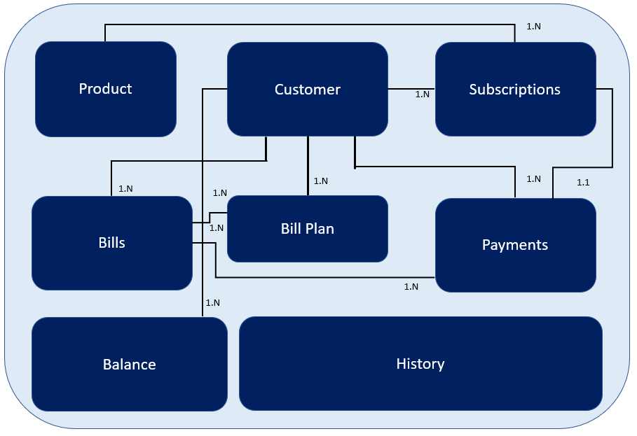

The above diagram also shows the entity relationship between the different subject areas.
Following are the steps which are followed to arrive at the Data model which are important for taking the KPI/reports for Dell.
- Identify the subject areas which are relevant for the reports/KPIs generation
- Create the Conceptual, Logical and Physical Data Models
- Mapping between the source table columns and the fields of the Physical model, so that it helps for ETL to focus on those columns at staging tables.

The Data model relevant for each KPI/reports are explained in the relevant sections. Please refer to the KPI, Reports sections for the data model information

Slow Changing Dimension (SCD)
SCD (Slowly Changing Dimensions) Type 2 should be considered on the need basis only where it is required to keep track the changes. Otherwise SCD Type 1 is considered.

In-Memory Columnar Database, Materialized View considerations
Oracle’s In-Memory columnar storage and materialized views feature will be used for displaying the KPI/reports on the UI layer. The KPI/reports is segregated into the below categories.
- KPIs/reports generation for the dashboards with pre-defined criteria, timeline [ say last 1-year data]
- KPI/Report with drill-down having multiple dimension criteria

Below solution must be considered for each of the above mentioned KPIs/Reports.
- Materialized Views for Dashboards
In order to display the KPI/reports for the pre-defined timeline i.e. for last 1 year which will be displayed on UI, materialized views will be created.
- Materialized view can be created for the Main Fact tables [ for the KPIs with the two dimension/pre-set dimension criteria] in order to provide the data to generate the graphs and display it on dashboard.
- The refresh timeframe for the materialized view will be analyzed on each of the report and will be considered while creating the materialized views.
- UI should query these materialized views to fetch the data, generate the graphs using D3JS and display it on the page

Note: - Please note that there will be a lag in the data which will be provided to UI as the materialized views will be refreshed at the configured frequency. Even though there is minimal lag in getting the data, but usage of materialized views will provide the good performance on the queries which we execute and provide the good experience to Users.

- In-Memory Columnar store for KPIs/Reports to be generated with multiple criteria/drill down [ Not fixed time period]
Oracle’s In-Memory columnar store feature will be used only when the real-time data is required for the KPI/report generation.
If rea-time data is not required for KPI/reports, then drill down can be done from the Dimension and Fact tables where Oracle In-Memory columnar is not enabled. Instead it can be achieved using Materialized view or by querying to Dimension and Fact tables where In-Memory is not enabled.
By having the In-Memory columnar store is enabled, the performance of the query will be at its best as the columns of Dimension/Fact tables which are mentioned as In-Memory will hold those columns onto the Cache. The query will be executed onto the cache and result set will be available will be much faster than query which will be performed on the physical columns.
Dynamic query should be built which can provide the required data by querying the columns which are stored In Memory of the given Dimension and Fact tables, so that UI can run this dynamic query with the input values, extract the data using JDBC, generate the graphs using D3JS libraries and display it on UI.
Following points should be considered for enabling the In memory database in Oracle 12c.
- Enable In-Memory Column store in when we create the database for EDW by setting the sufficient memory (Ex:- 4GB) for the INMEMORY_SIZE parameter. Setting of memory <<4GB>> should be analyzed and set based on the volume of data in the production environment.

- While creating the Fact tables, the columns which are required as result, set must be set as INMEMNORY so that those columns will be there in memory, so that whenever we query, the column data will be picked from the cache instead of physical table.

Note: - The details about what columns should be there in In-Memory for each of the Dimension and Fact tables will be specified in the schema creation scripts.
For achieving columnar store, we have to make sure that sufficient memory should be allocated for In Memory database and all the columns of the Fact and Dimension tables must be created with the Columnar store.

User Interface (UI) with D3 (Data Driven Documents)
A new web application Interface will be developed using Angular which can be accessed through web. In order to develop the front-end pages for the UI, bootstrap framework will be used.
- UI must be integrated to Dell’s LDAP/Active directory for login authentication. UI must make use of existing Dell’s service for login authentication
- For logging into UI, a different set of profiles must be created to provide the role-based access to UI.

A User Management module must be built in UI. A super user will have the access to it wherein he can create the access to the different web pages as per the requirements. The users and the required roles must be
<<
To be updated
>>

KPIs ( Key Performance Indicators)
This section covers the details like, the mock-up screen, data model, graphs etc. are defined for the different KPIs and reports which will be delivered as Sprint deliverables.

Churn Rate KPI
Dell’s customers who are subscribed for the services are decided to discontinue the services (within in contract or outside the contract) and decided not to renew the subscriptions is considered as Churn. With this KPI from UI, User can see what the Churn rate is based on the below different dimensions against time.
    - Offer/Service Type
    - Customer Segment (Consumer / Commercial Customers)
    - Product Cadence (like Monthly, Annual)
    - Pay Type
    - Country
    - Company

Mock-Up Screens
This section shows the different Churn rate graphs which will be generated for each of the dimensions mentioned in the above section.

Churn KPI based on Customer Segment

Data Model
This section outlines the approach on identification of the relevant subject areas, source tables and arriving at the EDW Data model.

Impacted Subject Areas
Below are the subject areas which are getting impacted for this KPI.
- Product
- Customer
- Subscriptions

Conceptual Data Model (CDM)
Below diagram represents the conceptual data model for the Churn KPI.

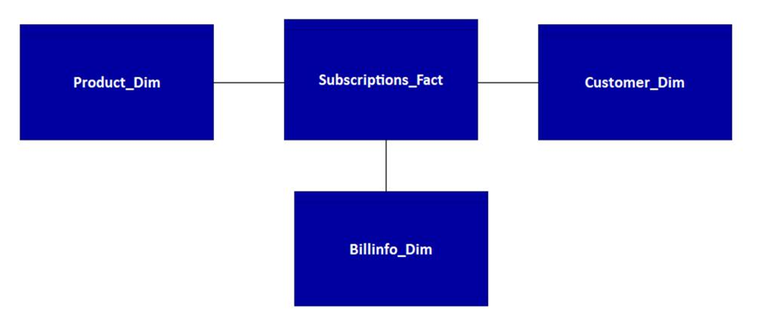

Logical Data Model (LDM)
Below diagram represents the logical data model for the Churn KPI.

Physical Data Model (PDM)
Below diagram represents the physical data model for the Churn KPI.

Subject Areas and Source Table Mapping
The different subject areas which are required and the source tables corresponding to each of the subject areas have been listed in this section.
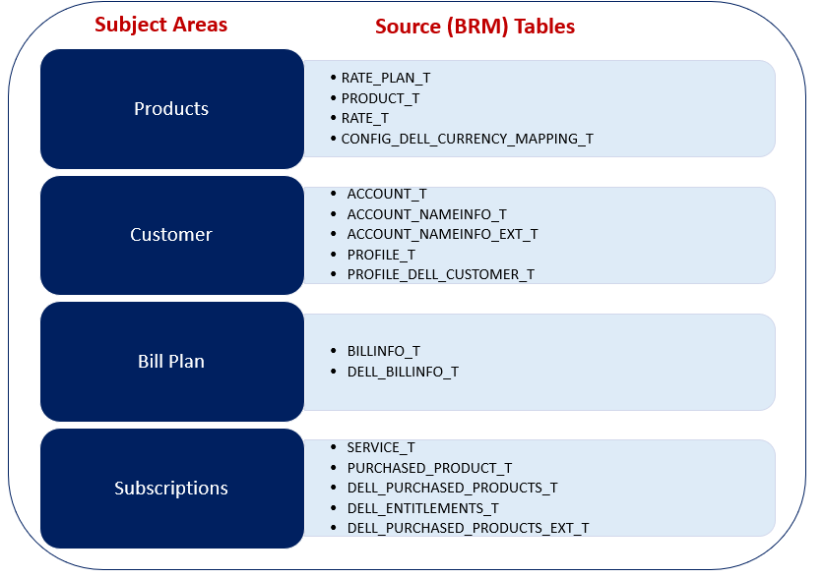
At the high level, this gives the information on what tables are necessary to referred to arrive at the EDW data schema.

Dimension & Fact Tables
For the Churn KPI, the different Dimension and Fact tables should be created as mentioned in the below table. The below table also shows what Data source tables should be considered to derive Dimension and Fact tables.
EDW TABLE NAME | DIMENSION/  FACT | DATA SOURCE TABLES
PRODUCT_DIM | DIMENSION | - PRODUCT_T  - RATE_PLAN_T  - RATE_T  - CONFIG_DELL_CURRENCY_MAPPING_T
CUSTOMER_DIM | DIMENSION | - ACCOUNT_T  - ACCOUNT_NAMEINFO_T  - PROFILE_T  - PROFILE_DELL_CUSTOMER_T
BILLINFO_DIM | DIMENSION | - BILLINFO_T  - DELLBILLINFO_T
SUBSCRIPTIONS_FACT | FACT | - PURCHASED_PRODUCT_T  - DELL_PURCHASED_PRODUCTS_T  - SERVICE_T  - DELL_ENTITLEMENTS_T

The physical data model which should be created in EDW as per the attached EDW data model sheet.

In-Memory Store & Materialized Views
As the business users will be interested to see the churn rate KPIs in a real-time, it is very important to make the data available in In-memory, so that the performance of query will be good.
For achieving this, the Dimensions & Fact Table columns on which the queries will be executed for generating the Churn KPI should be identified and made available in In-Memory. Also, we have to make sure that the data present In-Memory should be compressed.
Choosing In-Memory option for generating Churn KPI has been decided based the below parameters.
- Requirement of real-time availability of Churn KPI
- Volume of data in Fact and Dimension tables
Note: - Please refer to the Dimension & Fact schema creation scripts which will be delivered as part of the Source code deliverables.

The users will extract the Churn KPIs with any of the below mentioned criteria.
- KPI generation using Materialized Views for fixed two-dimension criteria

In order to provide the KPI for the fixed two dimensions like Churn KPI for last 1 year for the Office365 product, materialized views should be created with the refresh rate minimum of <<X minutes>>, so that UI can query to these materialized views rather querying the actual tables/columnar store. This provides the better user experience as the time taken for viewing the KPI on UI will be instantaneously.

But the only disadvantage is user will be viewing the KPI having the data with the lag of <<x minutes>>

Note: - Please note that the time for refreshing to materialized views should be fine-tuned after analyzing in the production data and the has to be agreed with technical design approving authority team and has to be set.

The UI should query to this materialized view through webservice/Rest API, fetch the result set and generate the graphs using D3JS libraries and display it on UI.

- KPI generation using In-Memory Columnar store for multi-dimension criteria
For the generation of KPI, dynamic query should be developed which can accept the multiple criteria dynamically and the query must be executed on the In-Memory columnar store and provide the result set back to UI through webservice/Rest API.
The time taken for executing the dynamic query on In-memory columnar store will be better than the querying the Fact tables without In-Memory columnar store.

Churn Rate Formula
The queries to be developed in EDW to generate the different Churn Rate KPIs from EDW and the corresponding result set to be provided to UI to display it using D3JS graphs.
For calculating the Churn rate, the below formula must be used.
Churn Rate Calculation formula
Churn Rate = (Cancellations / Customers Average)

Cancellations = (
No. of Customers at the Start Date of Churn rate calculation +
New Customers in the Churn calculation period –
No. of Customers at the End Date of Churn rate calculation
)

Churn KPIs with fixed criteria for Dashboards
As explained in the earlier section, for displaying the Churn score KPIs with two-dimension criteria, UI should query the materialized view.
The below table shows the logic for each of the dimensions for which Churn KPIs are calculated. Materialized view should be created by using the below implementation logic by querying the Fact & Dimension tables and with the refresh rate of <<x Minutes>>.
UI should query the materialized views for fetching the Churn KPI result set and display it as graphs.
Sl. No | Churn Type | Churn KPI  criteria | Implementation Logic | Output
1 | Service wise | - Time (Churn period Start & End datetime)  - Service Name | - Query the SUBSCRIPTIONS_FACT table and Group By with the below fields and the conditions  - SUBSCRIPTIONS_FACT.service_name =” << Service Name as input>>”  - purchase_end_date between << Churn Period Start date >> and << Churn Period end date >>  - purchased_product_status = (2, 3)  Note: Please note that the product status having In-Active are also considered. The same will be depicted on the graphs  Group by Service Name | - Service Name  - Churn Rate
2 | Product wise | - Time (Churn period Start & End datetime)  - Product/Offer Name | - Query the SUBSCRIPTIONS_FACT table and Group By with the below fields and the conditions  - Join SUBSCRIPTIONS_FACT, PRODUCT_DIM using product_obj_id0  - PRODUCT_DIM.Product_description = << Product Name >>  - purchase_end_date between << Churn Period Start date >> and << Churn Period end date >>  - purchased_product_status = (2, 3)  Group by Product Name | - Product/Offer Name  - Churn Rate
3 | Product Cadence | - Time (Churn period Start & End datetime)  - Product Cadence | - Query the SUBSCRIPTIONS_FACT table and Group By with the below fields and the conditions  - SUBSCRIPTIONS_FACT.product_cadence =” << product cadence ex: - 1(Monthly) or 12(Annual)>>”  - purchase_end_date between << Churn Period Start date >> and << Churn Period end date >>  - purchased_product_status = (2, 3)  Group by Product cadence | - Product Cadence  - Churn Rate
4 | Country/ BUID  wise | - Time (Churn period Start & End datetime) | - Query the SUBSCRIPTIONS_FACT table and Group By with the below fields and the conditions  - Join SUBSCRIPTIONS_FACT, CUSTOMER_DIM using account_obj_id0  - CUSTOMER_DIM.order_buid= << BUID>>  - purchase_end_date between << Churn Period Start date >> and << Churn Period end date >>  - purchased_product_status = (2, 3)  Group by Country / BUID | - Country/BUID  - Churn Rate
5 | Customer segment wise  (Consumer/  Commercial) | - Time (Churn period Start & End datetime)  - CNS/CMR  (Consumer/  Commercial) | - Query the SUBSCRIPTIONS_FACT table and Group By with the below fields and the conditions  - Join SUBSCRIPTIONS_FACT, CUSTOMER_DIM using account_obj_id0  - CUSTOMER_DIM.dell_customer_segment = << CNS/CMR>>  - purchase_end_date between << Churn Period Start date >> and << Churn Period end date >>  - purchased_product_status = (2, 3)  Group by customer segment | - Customer Segment  - Churn Rate
6 | Company wise | - Time (Churn period Start & End datetime) | - Query the SUBSCRIPTIONS_FACT table Group By with the below fields and the conditions  - Join with SUBSCRIPTIONS_FACT, CUSTOMER_DIM using account_obj_id0  - company_name like << >>  - purchase_end_date between << Churn Period Start date >> and << Churn Period end date >>  - purchased_product_status = (2, 3) | - Company Name  - Churn Rate
7 | Pay Type | - Time (Churn period Start & End datetime)  - Pay Type  (INVOICE/ CREDIT_CARD/  DIRECT_DEBIT/ SUBORDINATE  ) | - Query the SUBSCRIPTIONS_FACT table Group By with the below fields and the conditions  - Join with SUBSCRIPTIONS_FACT, BILLINFO_DIM using account_obj_id0  - pay_type in << pay type>>  - purchase_end_date between << Churn Period Start date >> and << Churn Period end date >>  - purchased_product_status = (2, 3)  If Pay_type is not specified, Group by Pay_type | - Pay Type  - Churn Rate
8 | Churn KPI with multiple criteria | - Time (Churn period Start & End datetime)  - Combination with any of the criteria (Sl. No. 1-7) | If User drills down with multiple criteria  - For the Churn KPI on multiple criteria which cuts across the different dimensions, a stored procedure must be developed to build a dynamic query with the different attributes passed from UI and get the result set by querying FACT table.  - The result set will be passed to D3JS where appropriate graphs are generated and passed to UI | - Any other Dimension names in combination [ Sl.No. 1-7]  - Churn Rate

Churn KPIs with drilldown (multiple dimension Criteria)
If a user wants to drill down from the dashboard and wish to view the Churn KPI with the more than two dimensions i.e. multiple criteria, then UI must call the webservice which should be created newly, which can call the function which invoke the dynamic query at EDW. Dynamic query will execute and fetch the data from the In-Memory columnar store and display it on UI.
Sl. No | Churn Type | Churn KPI  criteria | Implementation Logic | Output
1 | Churn KPI with multiple criteria | - Time (Churn period Start & End datetime)  - Combination with any of the criteria (Sl. No. 1-7) | If User drills down with multiple criteria  - For the Churn KPI on multiple criteria which cuts across the different dimensions, a stored procedure must be developed to build a dynamic query with the different attributes passed from UI and get the result set by querying FACT table.  - The result set will be passed to D3JS where appropriate graphs are generated and passed to UI | - Any other Dimension names in combination [ Sl.No. 1-7]  - Churn Rate

Reports

Performance Analysis Report
Performance analysis on the sample queries performed on SUBSCRIPTIONS_FACT table with the In-Memory Columnar store and without In-Memory Columnar store options. Almost 10 Million records were maintained, and the analysis output shows that by using the In-memory columnar store improves the performance by 30%. Below is the analysis report for the sample query.

------------------------------------------------------------- End of Document---------------------------------------------------------

